|  |
| --- |
| **INDUSTRY INTERNSHIP REPORT**  ***Submitted in***  ***partial fulfillment of requirement for the award of degree of***  **Bachelor of Technology**  **in**  **Electronics and Telecommunications Engineering**  ***by***  **Ms. Vrushali Rahate**  ***Industry / Organization Guide***  **Mr. Sandesh Rahate**  Principal- Technology Consulting, Modern Solution at  **Hitachi Solutions India Pvt. Ltd.**  ***Institute Guide***  **Dr. Sanket Kasturiwala**  Associate Professor  **May 2025**    **Department of Electronics and Telecommunications**  **G H Raisoni College of Engineering and Management**  An Empowered Autonomous Institute affiliated to Rashtrasant Tukadoji Maharaj Nagpur University, Nagpur Accredited by NAAC with “A++” Grade (3rd Cycle)  Shraddha park, B-37-39/1,MIDC, Hingna Wadi Link Road, Nagpur-440016(INDIA)  T: +91 9604787184, 9689903286, 9921008391 | E: principal.ghrce@raisoni.net |W: ghrce.raisoni.net |

|  |
| --- |
| **INDUSTRY INTERNSHIP REPORT**    ***Submitted in***  ***partial fulfillment of requirement for the award of degree of***  **Bachelor of Technology**  **in**  **Electronics and Telecommunications Engineering**  ***by***  **Ms. Vrushali Rahate**  ***Industry / Organization Guide***  **Mr. Sandesh Rahate**  Principal- Technology Consulting, Modern Solutions at  **Hitachi Solutions India Pvt. Ltd.**  ***Institute Guide***  **Dr. Sanket Kasturiwala**  Associate Professor  **May 2025**    **Department of Electronics and Telecommunications**  **G H Raisoni College of Engineering and Management**  An Empowered Autonomous Institute affiliated to Rashtrasant Tukadoji Maharaj Nagpur University, Nagpur Accredited by NAAC with “A++” Grade (3rd Cycle)  Shraddha park, B-37-39/1,MIDC, Hingna Wadi Link Road, Nagpur-440016(INDIA)  T: +91 9604787184, 9689903286, 9921008391 | E: principal.ghrce@raisoni.net |W: ghrce.raisoni.net  © |

|  |  |  |  |  |  |  |  |  |
| --- | --- | --- | --- | --- | --- | --- | --- | --- |
| **Declaration**  I hereby declare that the Industry Internship report submitted herein has  been carried out by me in Hitachi Solutions India Pvt. Ltd. towards partial fulfillment of requirement for the award of Degree of Bachelor of Technology in Electronics and Telecommunications. The work is original and has not been submitted earlier as a whole or in part for the award of any degree / diploma at this or any other Institution University.  I also hereby assign to G H Raisoni College of Engineering and Management, Nagpur all rights under copyright that may exist in and to the above work and any revised or expanded derivatives works based on the work as mentioned. Other work copied from references, manuals etc. are disclaimed.   |  |  |  |  | | --- | --- | --- | --- | | **Name of student** | **Mobile No** | **Mail ID**  **(Other than Raisoni.net)** | **Signature** | | Vrushali Rahate | 8381028985 | vru2802@gmail.com |  |   **Place: Nagpur**    **Date: 17/06/2025** |

|  |
| --- |
| **Certificate**  The Industry Internship Report entitled as **“Tru Medico”** carried out under our  supervision in **Hitachi Solutions India Pvt. Ltd.** by **Vrushali Rahate** for the award of Degree of Bachelor of Technology in Electronics and Telecommunications. The work submitted is comprehensive, complete and fit for evaluation.  **Mr. Sandesh Rahate Dr. Sanket Kasturiwala**  **Industry / Organization Guide Institute Guide**  Principal- Technology Consulting, Associate Professor  Modern Solutions Department of Electronics  Hitachi Solutions India Pvt. Ltd. And Telecommunications  GHRCEM, Nagpur      **Dr. Sanket Kasturiwala Dr. Devashree Marotkar**  III Coordinator Head of Department  GHRCEM, Nagpur Electronics and Telecommunications  GHRCEM, Nagpur  **Mr. Gurpal Singh Dr. Vivek Kapur**  III Cell **Director**  GHRCEM,Nagpur GHRCEM,Nagpur |

**ACKNOWLEDGEMENT**

I would like to express my sincere gratitude and appreciation to the following individuals who have provided invaluable guidance, support, and expertise throughout my internship at Hitachi Solutions India Pvt Ltd.

I am deeply grateful to **Mr. Sandesh Rahate(Principal- Technology Consulting, Modern Solutions) ,Mr. Hiten Bhatt(Enterprise Architect), Mr. Dinesh Mudaliyar(Specialist-Technical)** for their exceptional guidance, mentorship, and expertise throughout my internship.

I attribute the success to my institute guide and Coordinator **Dr. Sanket Kasturiwala, Associate Professor, Department of Electronics and Telecommunications Engineering, GHRCEM, Nagpur** whose tireless efforts, timely and esteemed guidance and encouragement enabled me to complete this challenging job within stipulated time period.

We express our sincere gratitude to **Dr. Devashree Marotkar, Head of the Department of Electronics and Telecommunications Engineering** for her stimulating guidance.

Our sincere thanks go to the Honorable **Director, Dr. Vivek Kapur, GHRCEM, Nagpur** for his genuine concern and for providing the necessary facilities to carry out the work. We are grateful to our **Dean of Industry Relations, Mr. Gurpal Singh**, for their cooperation in the completion of this project. I am truly grateful for the opportunities and experiences I have gained during my internship, and I look forward to applying the knowledge and skills acquired in my future endeavor.

# ABSTRACT

This project presents a comprehensive Pharmacy Management System designed to streamline medicine sales, inventory tracking, order processing, and user interactions in an online environment. The system facilitates seamless login, registration, and role-based access for admins and users. Admins can efficiently manage product listings, categorize medicines, track stock levels, and handle customer orders, while users can browse medicines, add items to a cart, place orders, and manage addresses. The application aims to enhance the customer experience by offering a user-friendly interface and optimized backend architecture using Angular for the frontend and ASP.NET Core for the backend.

A key feature of the system is the integration of secure payment processing through mock gateways Stripe, enabling card payments and managing returns with appropriate workflows. Users can view order history and track delivery status, while admins have tools to update order statuses, approve return requests, and handle refunds for card payments via Stripe.

Cash-on-delivery return requests are directed to support channels, ensuring operational clarity. The system also supports address management, with options to update billing and shipping addresses dynamically from the user profile.

The project emphasizes data integrity, secure authentication using JWT tokens, and real-time communication between components through well-defined APIs. It includes features like quantity adjustment in the cart, category-based product sorting, and admin analytics.

This Pharmacy Management System not only automates the traditional pharmacy workflow but also enhances transparency, efficiency, and user satisfaction in medicine ordering and return handling processes.

**LIST OF FIGURES**

|  |  |  |
| --- | --- | --- |
| **Figure No.** | **Figure Name** | **Pg. No.** |
| 1.1 | Hitachi Solutions Pvt. Ltd. Logo | 2 |
| 2.1 | Login Page of Tru Medico | 15 |
| 2.2 | Tru Medico Home Page | 15 |
| 2.3 | Product listing page of Tru Medico | 16 |
| 2.4 | Best Seller Section of Tru Medico | 16 |
| 2.5 | AI Chatbot (Med Buddy) | 17 |
| 2.6 | User Specific Account Section | 17 |
| 2.7 | User Specific Cart | 18 |
| 2.8 | Dynamic Address Editing | 18 |
| 2.9 | Payment Options | 19 |
| 2.10 | Admin Dashboard | 19 |
| 2.11 | Admin Dashboard Functionalities | 20 |
| 2.12 | Dedicated Order Details Page for Admin | 20 |
| 2.13 | Dedicated Order Details Page for Admin | 21 |

**LIST OF APPENDICES**

|  |  |  |
| --- | --- | --- |
| **App No.** | **Figure Name** | **Pg. No.** |
| A | Photo with industry guide | 26 |

**INDEX**

|  |  |  |
| --- | --- | --- |
| **Sr. No** | **Content** | **Page No.** |
| 1 | CHAPTER 1: Introduction to Company |  |
| 1.1 | About the Company | 1 |
| 1.2 | Historical Background | 2 |
| 1.3 | Location | 3 |
| 1.4 | Operational Structure | 4 |
| 1.5 | Mission and Vision | 5 |
| 1.6 | Product Manufactured | 6 |
| 2 | CHAPTER 2: Case Study |  |
| 2.1 | Introduction | 9 |
| 2.2 | Problem Identification | 10 |
| 2.3 | Objectives | 11 |
| 2.4 | Work carried out | 12 |
| 2.5 | Solution Provided | 13 |
| 2.6 | Methodology Overview | 14 |
| 2.7 | Results and Conclusions | 16 |
| 3 | References | 24 |
| 4 | Appendices | 26 |

# CHAPTER I

**INTRODUCTION TO COMPANY**

## About the Company

Hitachi Solutions is a global IT services and systems integrator, recognized for its deep expertise in Microsoft technologies. As a core subsidiary of the Hitachi Group, it plays a pivotal role in delivering comprehensive digital transformation solutions across various industries, including manufacturing, healthcare, financial services, and retail.

Hitachi Solutions specializes in end-to-end digital transformation services, encompassing advisory, application innovation, artificial intelligence (AI), cloud platforms, data analytics, managed services, and security governance. The company is exclusively focused on the Microsoft ecosystem, leveraging tools such as Azure, Dynamics 365, and Power Platform to build tailored solutions for its clients .

A key component of their approach is the "Digital Compass™," a methodology that guides organizations through their digital journey—from readiness assessment and strategic road mapping to design, delivery, and ongoing support. This comprehensive framework ensures that clients receive holistic and sustainable solutions .

With over 3,500 professionals worldwide, Hitachi Solutions operates across North America, Europe, and Asia, including a significant presence in India. The company's global reach enables it to deliver localized solutions with a deep understanding of regional business challenges and opportunities

In 2024, Hitachi Solutions entered a strategic partnership with Microsoft to advance the adoption of generative AI. This collaboration integrates Microsoft's AI tools into Hitachi's Lumada platform, aiming to accelerate digital transformation and enhance productivity across industries . Additionally, Hitachi Solutions has partnered with Google Cloud to further bolster its AI capabilities and business solutions .

Hitachi Solutions is dedicated to driving Sustainability Transformation (SX) by addressing societal and business challenges through innovative digital solutions. The company collaborates with global partners to create value that contributes to a sustainable society, aligning with Hitachi's broader mission of "Inspire the Next"

As a trusted Microsoft partner, Hitachi Solutions stands out for its deep technical expertise, customer-centric approach, and commitment to driving meaningful digital transformation. By combining innovative technology with a focus on sustainability, the company continues to empower organizations worldwide to navigate the complexities of the digital age.



### Fig 1.1 Hitachi Solutions India Pvt. Ltd. Logo

## Historical Background

Hitachi Solutions, Ltd. traces its origins to the early 20th century, rooted in the pioneering spirit of Hitachi, Ltd., founded in 1910 by electrical engineer Namihei Odaira. Odaira's development of Japan's first 5-horsepower electric motor marked a significant milestone in industrial innovation.

In September 1970, Hitachi established Hitachi Software Engineering Co., Ltd., which later evolved into Hitachi Systems & Services, Ltd. This entity became a key player in IT solutions and services, laying the groundwork for the company's future endeavors in the digital realm.

A pivotal moment occurred in 2004 when Hitachi acquired Iteration2, a Microsoft partner specializing in enterprise resource planning (ERP) solutions.

This acquisition led to the formation of Hitachi Consulting in 2007, which subsequently rebranded as Hitachi Solutions in 2012, aligning more closely with the Hitachi Group's identity and strategic direction. The company's expansion continued with the establishment of subsidiaries and affiliates across North America, Europe, and Asia, including significant operations in India. In 2015, Hitachi Solutions acquired Ignify, a leading provider of ERP, customer relationship management (CRM), point of sale (POS), and e-commerce software, further enhancing its capabilities in the Microsoft ecosystem. Today, Hitachi Solutions stands as a global IT services and systems integrator, recognized for its deep expertise in Microsoft technologies and its commitment to delivering comprehensive digital transformation solutions across various industries.

## 1.3 Location

Hitachi Solutions maintains a robust global presence with offices strategically located across North America, Europe, Asia, and India. Here are some of its key office locations:

In India : Pune, Bangalore, Chennai

Headquarters: 4-12-7 Higashishinagawa, Shinagawa-ku, Tokyo 140-0002, Japan

## Operational Structure

Hitachi Solutions, Ltd. operates under a structured organizational framework designed to facilitate efficient management and delivery of its IT services and solutions. The company's operational structure is centered around several key divisions and groups, each focusing on specific aspects of its business operations.

**1.4.1 Executive Leadership**

* **President and CEO**: Hideji Morita, President and Chief Executive Officer
* **Senior Vice Presidents and Executive Officers**: Jinichi Hirano, Hideji Morita
* **Vice Presidents and Executive Officers**: Takeshi Akiyama, Naohiko Kagawa, Hideki Taya, Hiroaki Handa, Jirou Watabe, Hiroki Ito, Tooru Oike, Souichirou Ohara, Tetsuya Kato, Akira Sato, Tetsuya Cho, Satoko Tsukiori, Takashi Hino, Takeshi Yoshikawa
  + 1. **Core Divisions**

**1.4.2.1 Business Divisions**: These divisions are responsible for delivering specialized solutions to various sectors.

* + **Sustainable City Business Division**
  + **Industrial Innovation Business Division**
  + **Smart Life Solution Business Division**
  + **Business-Innovation Business Division**
  + **IT Platform Business Division**
  + **Security Solutions Business Division**

**1.4.3 Support and Management Divisions**: These groups provide essential support functions across the organization.

* + **Technical Innovation and Management Group**
  + **Quality Assurance Group**
  + **Procurement Management Group**
  + **Corporate Strategy Management Group**
  + **Finance Management Group**
  + **Human Capital & General Affairs Group**

**1.4.4 Oversight and Governance**:

* + **Audit Office**: Ensures compliance and internal control across operations.

**Global Presence**

Hitachi Solutions has a significant international footprint, with key subsidiaries in Asia, the United States, and Europe. This global presence enables the company to deliver IT solutions and services tailored to the specific needs of diverse markets

This organizational structure reflects Hitachi Solutions' commitment to delivering high-quality IT services and solutions, leveraging its global expertise and specialized divisions to meet the evolving needs of its clients.

Bottom of Form

## 1.5 Vision and Mission of Company

### 1.5.1 Vision Statement

Deliver new perspective of globalization and digitalization to all.

Accelerate collaboration that inspires revolution. Build societies in which new values can be enjoyed by everyone.

### 1.5.2 Mission Statement

Look forward and spearhead change. Create a bright future for the global community collectively with reliable technologies and advanced solutions.

## 1.6 Product Manufacture

### 1.6.1 Nature of Products

Hitachi Solutions India is primarily involved in developing enterprise-level digital products that serve industries like manufacturing, retail, finance, and healthcare. The nature of these products is mostly solution-oriented and aligned with business process automation, digital transformation, and data-driven decision-making. A large portion of their product offerings is based on Microsoft technologies—especially Dynamics 365, Power Platform, and Azure services. Their work often revolves around ERP systems, CRM solutions, AI-integrated tools, and industry-specific software that improves business efficiency and customer engagement. These are not generic applications, but highly customizable, scalable, and secure systems built to meet specific client needs across global markets.

### 1.6.2 Development Methodology

In terms of development methodology, Hitachi Solutions follows Agile and DevOps practices extensively. Agile allows the teams to build software iteratively, release updates regularly, and remain flexible to client feedback. Each product goes through multiple sprint cycles, which involve planning, development, testing, review, and retrospective phases. The use of Scrum boards and daily stand-ups ensures that teams stay on track and bottlenecks are resolved quickly. DevOps complements this by automating deployment, testing, and monitoring, enabling faster and more reliable delivery of software. Together, Agile and DevOps enable the company to reduce time-to-market while maintaining product quality.

### 1.6.3 Technology Stack

The technology stack used by Hitachi Solutions India is predominantly based on Microsoft’s ecosystem, reflecting their specialization and partnership status with Microsoft. Backend services are built using .NET Core and C#, while frontends are developed using modern JavaScript frameworks such as Angular and React. Data storage and management rely on Microsoft SQL Server, Azure SQL, and Cosmos DB. For cloud infrastructure, Azure is the default choice, offering scalability, security, and seamless integration with other Microsoft services. The products also utilize Dynamics 365 for business logic and Power Platform tools like Power Apps, Power BI, and Power Automate for building low-code applications and business process workflows.

### 1.6.4 Quality Assurance and Testing

Quality assurance and testing are a core part of the product lifecycle at Hitachi Solutions India. The company employs a combination of manual and automated testing strategies to ensure every release is stable, secure, and functionally complete. Automation testing is implemented using tools like Selenium and Azure DevOps Test Plans, while APIs are validated with tools like Postman. Continuous Integration and Continuous Deployment (CI/CD) pipelines integrate automated test cases at every stage of the build process, helping to detect bugs early. Additionally, User Acceptance Testing (UAT) is carried out in collaboration with clients to validate that the product aligns with business expectations.

### 1.6.5 Integration of Advanced Technologies

Advanced technologies are actively integrated into their products to add intelligence and innovation. Artificial Intelligence and Machine Learning are embedded to power features like predictive analytics, sentiment analysis, recommendation engines, and intelligent automation. Internet of Things (IoT) capabilities are included in industry-specific applications, especially in manufacturing and asset tracking. There are also instances of Augmented Reality and Virtual Reality (AR/VR) being used for training modules and remote support scenarios, especially in field service applications. These advanced tech layers help make the software future-ready and more valuable for clients.

### 1.6.6 Deployment and Maintenance

Once the development is complete, deployment is managed using robust DevOps pipelines. These pipelines automate the building, testing, and deployment process, ensuring smooth releases across environments like development, staging, and production. Azure DevOps is the primary tool used for managing these pipelines, and deployments are monitored using tools like Application Insights and Azure Monitor. After deployment, the company continues to offer full lifecycle maintenance, which includes bug resolution, feature enhancements, version upgrades, and real-time monitoring. Clients are supported through help desks and SLA-based support teams to ensure uninterrupted business operations.

# 

# CHAPTER II

# CASE STUDY

## 2.1 Introduction

In today’s rapidly evolving digital world, the healthcare sector has witnessed significant technological advancements, especially in the management of pharmaceutical services. **Tru Medico**, A **Pharmacy Management System** is one such innovation aimed at streamlining the buying, selling, and administration of medicines.

This system serves as a comprehensive web-based solution that addresses the limitations of traditional pharmacy operations by introducing digital efficiency, convenience, and automation.

The core idea behind developing this project is to facilitate a seamless and secure platform where users can easily access a wide variety of medicines, place orders, make payments, and track their orders—all from the comfort of their home. On the other hand, the system also equips pharmacy administrators with robust tools to manage inventory, track sales, handle return requests, and maintain records effortlessly.

The digitization of such tasks not only reduces manual errors but also enhances customer satisfaction and operational efficiency.

This system bridges that gap, enabling 24x7 access to essential medications. Additionally, users are empowered with features like login/signup, order history, address book, cart operations, and even return and refund management.Security is a crucial element in any online transaction-based application. Hence, this system incorporates JWT-based authentication, role-based access control, and secure payment gateway like Stripe to ensure safe and smooth transactions. The integration of these technologies ensures that sensitive user information and transaction data remain protected.

Moreover, the use of modern frameworks such as Angular for frontend and .NET Core Web API for backend allows for a responsive, fast, and scalable solution. The entire system architecture has been built in a modular manner, ensuring easy maintenance and future scalability.

In summary, this Pharmacy Management System serves as a practical, real-world solution to the inefficiencies of traditional pharmacies. It demonstrates how technology can be leveraged to build an accessible, secure, and robust e-commerce platform dedicated to healthcare. By offering dual interfaces for users and administrators, the system meets both commercial and operational needs, making it a complete pharmacy solution.

## 2.2 Problem Identification

Traditional pharmacies often operate using manual systems for inventory management, billing, and order processing. This approach is prone to human error, delays, and inefficiencies.

Moreover, the absence of an online presence restricts customers from accessing essential medications conveniently, especially in rural areas or during health emergencies. The COVID-19 pandemic highlighted the need for online healthcare solutions more than ever before.

Some key problems identified include:

* **Limited accessibility**: Customers must visit a physical store to purchase medicines.
* **Manual operations**: Stock updates, billing, and order tracking are often manual.
* **Lack of return/refund processes**: Returning a product is complex and unrecorded.
* **No real-time order tracking**: Customers remain unaware of order status.
* **Insecure payments**: Many local systems do not support secure online transactions.

The Pharmacy Management System addresses all of these issues by providing an integrated digital platform. It ensures smooth communication between customers and the pharmacy, real-time updates, secure payment options, and the ability to manage orders, returns, and user data systematically.

This project was initiated to overcome these challenges and offer a centralized, automated, and easy-to-use system that benefits both users and pharmacy owners. With increasing internet usage and smartphone penetration, there is a growing demand for such platforms, and this project fulfills that market gap effectively.

## 2.3 Objectives

Tru Medico was developed with the following key objectives:

1. **To digitize medicine sales and purchases**: Build a platform where users can explore, search, and buy medicines online, anytime and anywhere.
2. **To enable effective inventory management**: Help admins add, update, or delete medicines, manage categories, and keep track of stock levels in real time.
3. **To ensure secure and seamless transactions**: Integrate verified payment gateways (Stripe) ensuring safety and reliability.
4. **To manage user roles and data**: Implement secure user authentication, role-based access (user/admin), and maintain user-specific order and address data.
5. **To handle order processing and returns efficiently**: Allow users to place, track, and return orders with transparency while enabling admins to approve or reject return requests.
6. **To support scalability and usability**: Design a modular, user-friendly web application that can be scaled easily for future updates or feature additions.

These objectives were focused on addressing real-life limitations in traditional pharmacy operations and creating a reliable online alternative that supports both customers and administrators. The system has been designed to enhance productivity, reduce manual workload, and provide a smoother and safer experience for medicine purchasing.

## 2.4 Work Carried Out

The project was executed in multiple stages, covering both frontend and backend development with database design and third-party integrations. The major modules developed are:

* **User Module**: Includes registration, login, JWT-based authentication, profile management, address book, and order history.
* **Admin Module**: Allows admins to add/edit/delete medicines, manage categories, view customer orders, handle return requests, and track payments.
* **Product Module**: Display products with filters and categories, stock tracking, product detail pages, and dynamic UI updates.
* **Cart & Checkout**: Users can add items to the cart, modify quantities, and proceed to checkout with selected addresses.
* **Payment Integration**: Integrated with Stripe (Card payments) for purchase and for refund processing.
* **Order & Return System**: Orders are saved post-payment. Users can request returns, and admins can approve/refund based on payment mode.
* **Address Management**: Users can add shipping and billing addresses, with options to reuse or update them during checkout.
* **AI Chatbot** : Users can interact with chatbot for queries like medicine availability,returns, refunds, tracking orders etc.

The system architecture was built using Angular (component-based UI), .NET Core Web API (RESTful services), and SQL Server (relational database). APIs were created for all CRUD operations, and front-end services were used to interact with these APIs. Payment and refund APIs were tested in sandbox mode. UI was developed using Bootstrap, Angular Material UI.

Throughout development, multiple test cases were written to validate business logic, form validations, and successful payment workflows. Each module was integrated step-by-step, tested, and optimized for performance and user experience.

## 2.5 Solution Provided

Tru Medico, the Pharmacy management system provides a full-stack, real-time, and secure digital solution to modernize pharmacy operations. It resolves the problems identified in manual systems by offering:

* A responsive **web application** accessible to both users and admins.
* **Login/Signup** with secure password hashing and JWT authentication.
* **Product listing** with dynamic filtering, category-wise browsing, and real-time stock updates.
* A **cart system** where users can manage quantities and view total prices before purchasing.
* **Order management** that saves each transaction with status tracking.
* A **return request module** that allows users to initiate returns, handled manually by admins.
* **Stripe Payment and refund API integration** for processing card payments and refunds.
* **Address book management** with options to add, edit, or reuse shipping and billing addresses.

The solution has a dual interface — user and admin — each tailored to their role. Admins can manage medicines, process returns, and track all activity through a dashboard. Users get a simplified shopping experience, quick checkouts, and order tracking.

By leveraging Angular, .NET Core, and third-party services like Stripe, this project offers a fully functional e-commerce solution designed specifically for pharmacies. It ensures speed, security, and scalability — all vital components of a modern healthcare application.

## 2.6 Methodology Overview

The methodology adopted follows the **Modular Full Stack Development** approach:

* **Frontend Development**:
  + Built using **Angular** with component-based architecture, Bootstrap, Angular Material UI, SweetAlert.
  + Features include routing, reactive forms, dynamic UI rendering, API integration, and local storage for tokens.
  + Services created for authentication, product handling, and cart operations.
  + Implementing guard for role based access.
* **Backend Development**:
  + Developed using **ASP.NET Core Web API**.
  + Clean architecture with Controllers, Data Transfer Objects(DTOs), Services, and Models.
  + JWT token generation and validation for secure authentication.
  + APIs for user registration, login, product management, cart, orders, returns, and payments.
* **Database**:
  + **SQL Server** used for relational database design.
  + Tables created for users, products, categories, carts, orders, addresses, and returns.
  + Entity Framework Core used for data access and migrations.
* **Payment Gateways**:
  + **Stripe sandbox** for simulating payments and refunds
  + Passwords hashed using industry standards.
  + JWT-based authentication with role-based access (admin/user).
* **AI Chatbot**
* Botpress AI used for Chatbot.
* Open-source chatbot builder with visual flow editor + AI brain
* Combines scripted flows and ChatGPT-like smart replies (via Autonomous Nodes)
* Supports RAG (Retrieval-Augmented Generation) — answers from your own files

The system was developed and tested in phases, with version control (Git) used for code tracking. UI/UX best practices were followed for smooth and mobile-responsive interfaces. Testing included unit tests for backend logic and form validation on the frontend

## 2.7. Results and Conclusions

### 2.7.1 Results

Th figure 2.1 shows the login page of Tru Medico.

**Fig. 2.1: Login Page of Tru Medico**

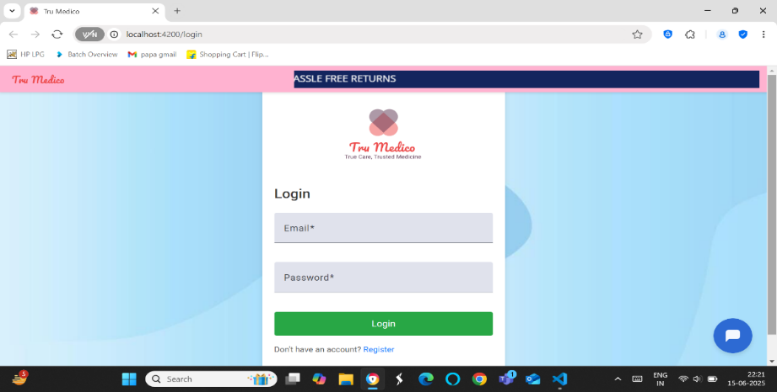

Fig. 2.2 shows the Home Page of Tru Medico. It displays the categories, search bar, and user specific profile.

**Fig. 2.**

**2**

**:**

**Tru Medico Home Page**

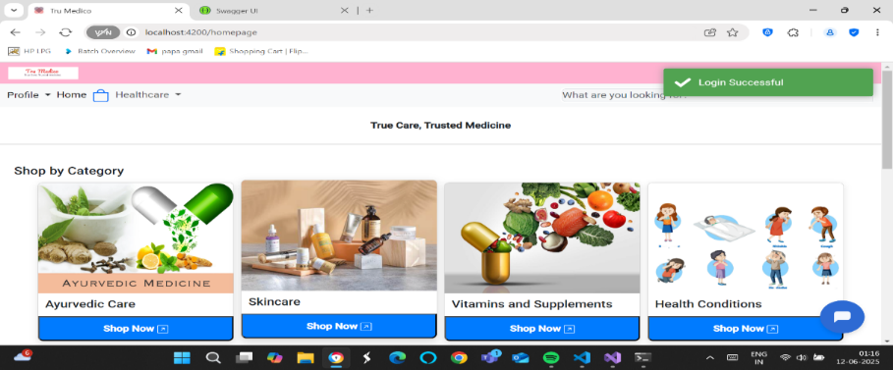

Fig. 2.3 shows the category wise product listing, which displays the name, description and price of specific product in rupees .

**Fig. 2.3: Product Listing Page of Tru Medico**

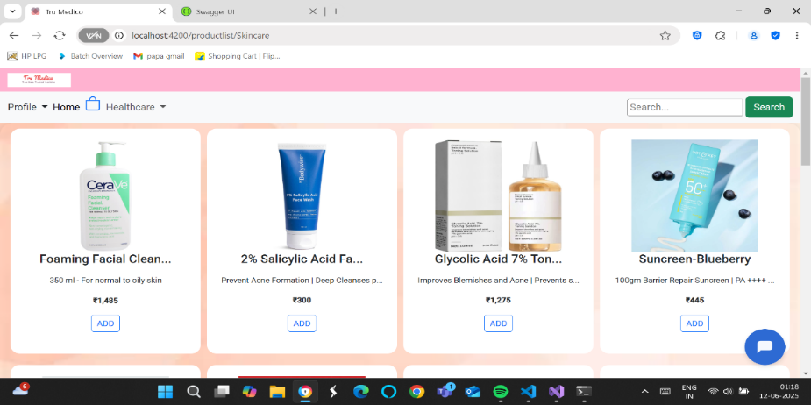

The best seller section shown in fig. 2.4, displays the top selling products of Tru Medico based on the total number of quantities of products sold in total orders, it gets updated regularly.

**Fig. 2.**

**4**

**:**

**Best Seller Section of Tru Medico**

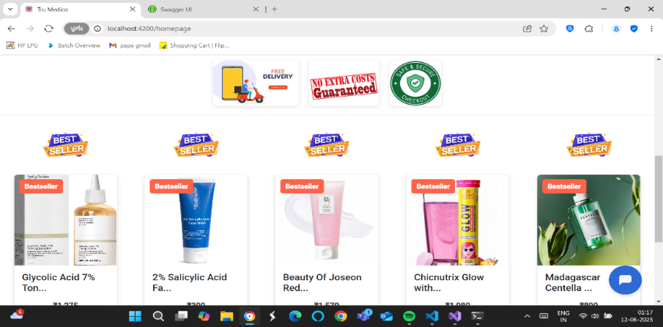

Fig. 2.5 shows the Chatbot implemented using Botpress AI,. This chatbot is trained using workflows and is trained to answer only site specific questions.

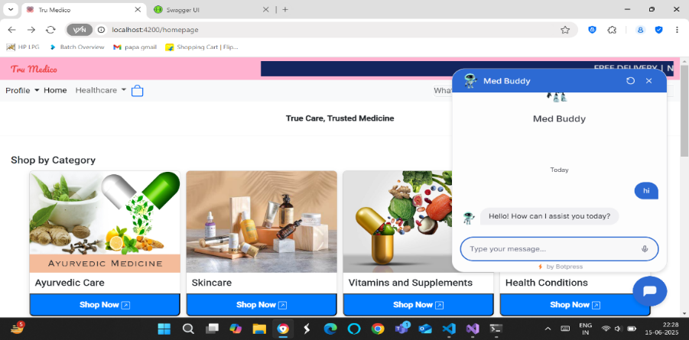

**Fig. 2.5: AI Chatbot ( Med Buddy)**

Fig. 2.6 displays the user specific account section which stores the user’s name, mobile number and address.

**Fig. 2.**

**6**

**:**

**User Specific Account Section**

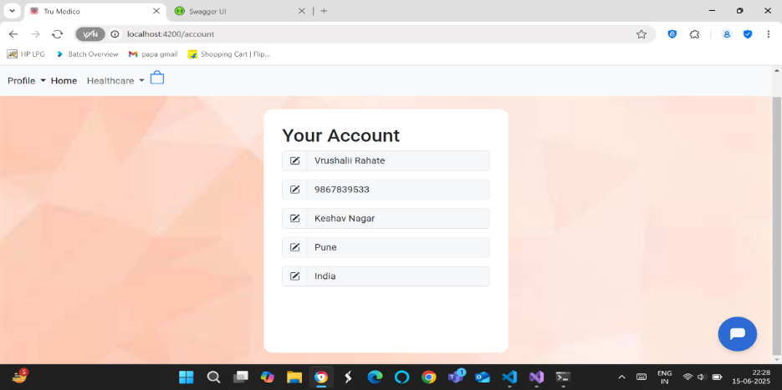

The fig. 2.7 displays user specific cart which allows users to update quantity, buy a single item or checkout multiple products.

**Fig. 2.**

**7**

**:**

**User Specific Cart**

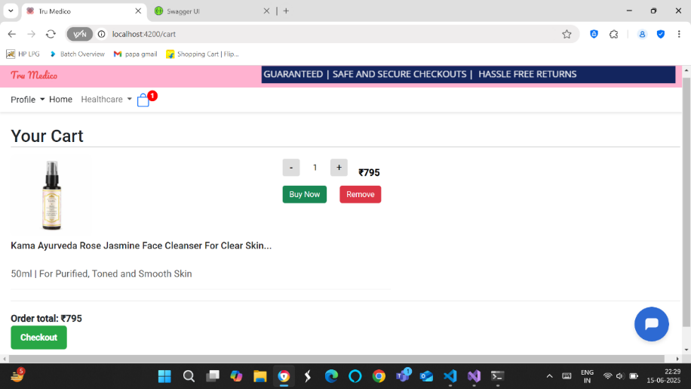

Fig 2.8 shows dynamic address filling and updating during the time of checkout.

**Fig. 2.**

**8**

**:**

**Dynamic Address Editing**

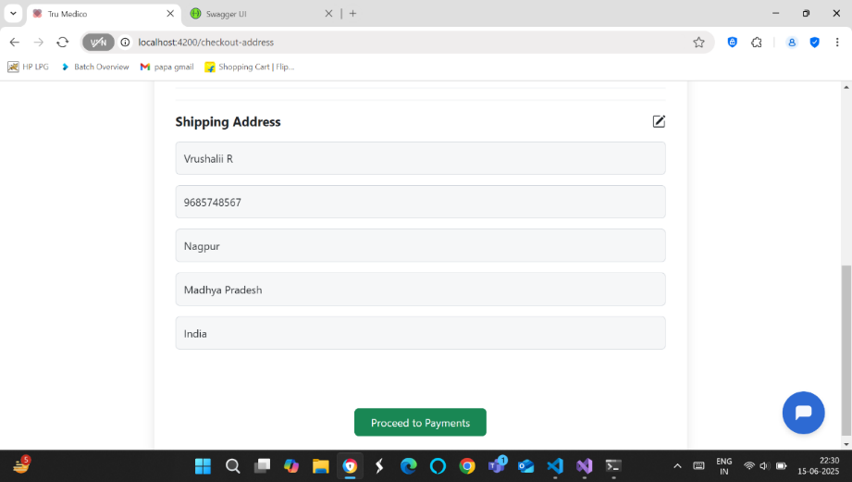

The fig. 2.9 shows two payment options Cash on Delivery and card payment using Stripe Payment Gateway.

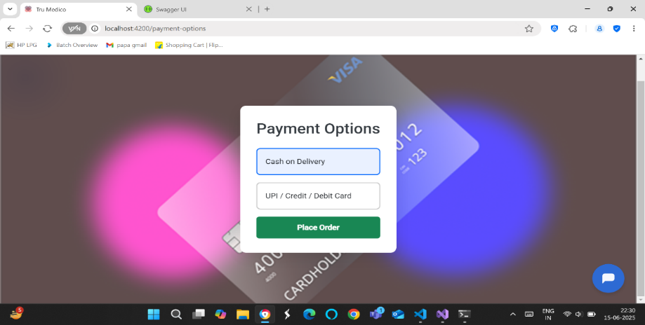

**Fig. 2.9: Payment Options**

Fig.2.10 displays the admin module of Tru Medico, this show the admin dashboard which consists of a month v/s sales chart.

**F**

**ig 2.**

**10:**

**Admin Dashboard**

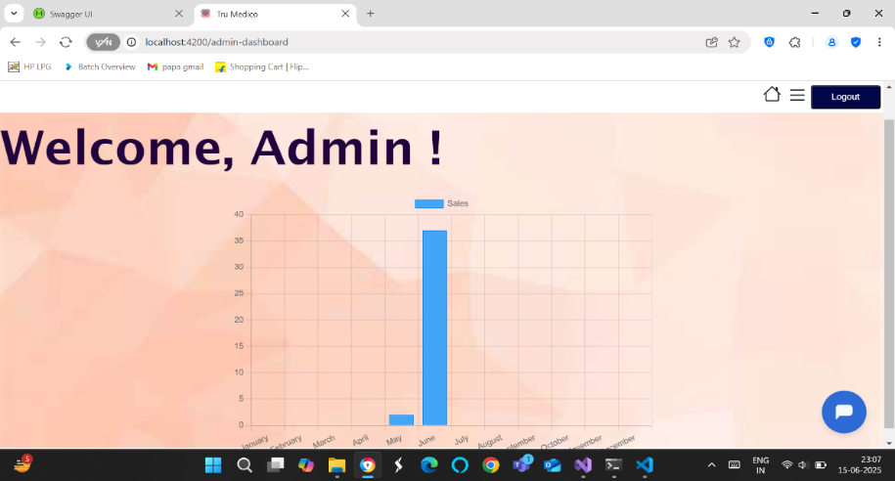

The fig. 2.11 shows the multiple functionalities available for the admin like, Adding medicines, Viewing the stock, viewing all the orders, out of stock medicines, Tru Medicine being a pharmacy website it is important to check expired medicines, so a dedicated page is designed to check the expired medicines.

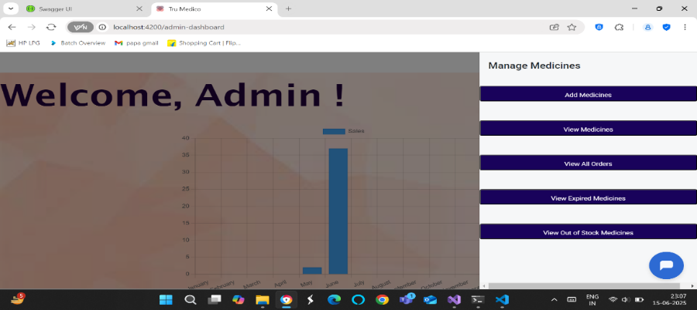

**Fig 2.11: Admin Module Functionalities**

Return and Refund is a crucial part of an e-commerce platform.The fig. 2.12 shows glimpse of the return page which gives the right to admin to approve or reject the return.

**Fig 2.12: Return Approve/Reject Page for Admin**

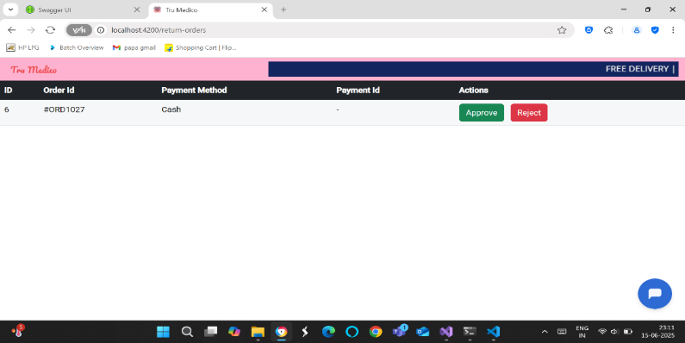

Fig. 2.13 shows the dedicated order details page for admin.

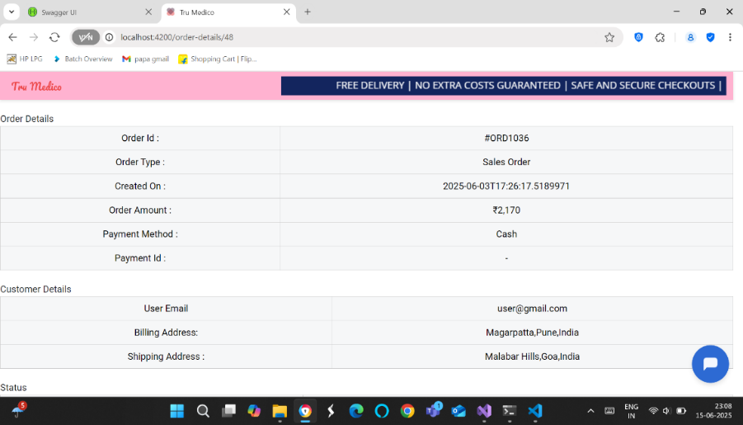

**Fig 2.13: Dedicated Order Details Page for Admin**

### 2.7.2 Conclusion

The "Tru Medico" Pharmacy Management System project successfully addresses the critical need for streamlined, digitized operations in pharmaceutical retail and inventory management. By automating key processes such as sales tracking, stock management, expiry alerts, and user authentication, the system reduces manual errors, enhances operational efficiency, and ensures a smoother experience for both customers and pharmacy staff.

The integration of modules like customer order management, real-time stock updates, and admin controls ensures that the pharmacy can run efficiently with better control and transparency.

From a technical standpoint, Tru Medico utilizes modern development tools and follows clean architectural principles to ensure scalability, maintainability, and security. The system's intuitive interface allows users to quickly learn and operate the software, reducing training time and human dependency.

Overall, this project demonstrates the potential of technology to bring meaningful improvements in the healthcare and retail sector. Tru Medico can serve as a solid foundation for further innovation— barcode scanning, or integration with diagnostic labs—making it a future-ready pharmacy management solution. This project not only enhances pharmacy workflow but also builds trust and transparency for end users.

# References

1. MicrosoftDocs – ASP.NET Core Web API  
   <https://learn.microsoft.com/en-us/aspnet/core/web-api>
2. Angular Official Documentation  
   https://angular.io/docs
3. Stripe API Documentation – Refunds  
   <https://stripe.com/docs/api/refunds>
4. Entity Framework Core – Microsoft Docs  
   <https://learn.microsoft.com/en-us/ef/core/>
5. W3Schools – Web Development Tutorials  
   <https://www.w3schools.com>
6. Research Paper: E-Pharmacy Management System  
   International Journal of Engineering Research and Technology (IJERT)  
   Volume 8, Issue 6, 2020
7. GeeksforGeeks – Full Stack Project Resources  
   <https://www.geeksforgeeks.org>
8. Hitachi Enterprise Chat

# APPENDICES

**A. Photo with Industry Guide**

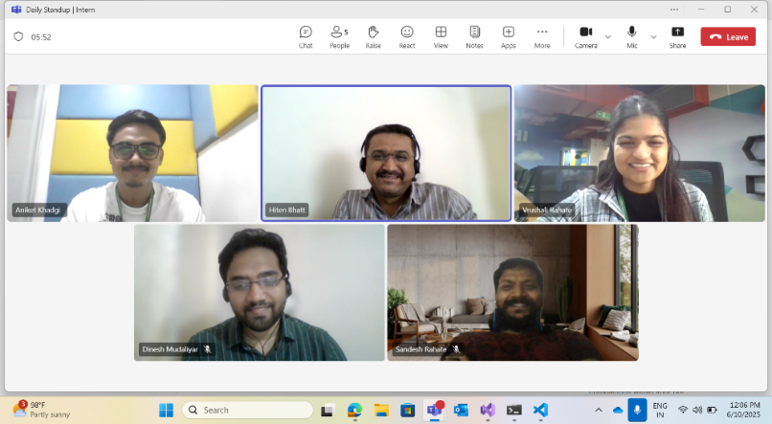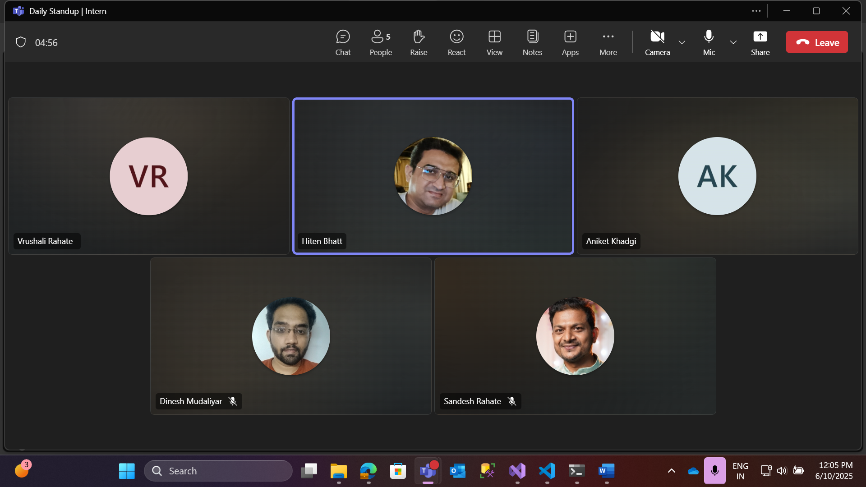

26